SILENTDUCK

One Time Pad Encryption

Training Manual

Prologue
This manual illustrates the theory, operation and use of SILENT DUCK, a manual one-time pad cipher method automated to reduce errors and processing time.
All elements in it have been field tested during much of the twentieth century by various governments entities. Throughout this document, derivatives of the words cipher and encryption are used interchangeably.

Introduction
The one time pad (OTP) is the only cipher mathematically proven to be uncrackable when used properly. It can be performed with pencil and paper using basic addition and subtraction, and will operate over any medium that allows communicating the digits zero through nine.
OTP requires prior key distribution unlike some other systems. For this it is generally shunned and, in some cases, derided by a number of prominent cryptographers.
Cryptography is the art of making and breaking procedures for efficiently scrambling and unscrambling of information in a manner that requires a secret key usually much smaller than all the data it scrambles. Properly executed, the one time pad system provides no opportunity for cryptographers to intrude.
World renowned cryptographer, Bruce Schneier, describes use cases where “simple key management is a solvable problem and the security requirement is timeshifting.” OTP works well for communication between parties that can share keys securely at a safe time in a safe environment, such as at HQ before deployment, and who then transport and keep them secure for use in future communication.
Security requirements are often not homogeneous for every link of the communication chain. Sometimes the originator of a message may have only pen and paper, some one time pad sheets, and be subject to electronic search before getting to a phone, radio transceiver or prearranged drop off point. The recipient, on the other hand, may have access to a computer that can send secure email and be able to forward the message on to the next link in the chain, oblivious to its contents.
OTP is different in that it also provides refutability for the communicants. An encrypted message can be trivially “decrypted” to any arbitrary text by easily fitting a key between the plain text and cipher text.
OTP remains a useful, practical and easy to use tool since nothing else quite fits its role.

Prerequisites
There are a few simple rules for ensuring that communications using the one time pad system remain completely uncrackable.
The key must be
- as long as the message
- generated from truly random data
- destroyed after a single use
- only have a single copy for each party

OTP Process
The sender of a message communicating with one time pads will do as follows:
- prepare a randomly generated list of digits to be used as a one time pad
- share the pad with the sender and the recipient
- encode the letters of the message into digits
- subtract the digits of the random one time pad (without borrowing) from the digits of the encoded message
- destroy the used key sheets
- transmit the result to the recipient
The recipient will take the results and process them using these steps
- add each digit of the random key to the message (without carrying)
- destroy the used key sheets
- convert the result into letters

Before anything communication can take place, the sender and receiver need to have a randomly generated one time pad. This pad must be generated from random data, not just a very long recurring stream of numbers. Merging random data from various sources cannot make them less random and is encouraged. There are many sources limited only by ones’ imagination. For training purposes, we can use that somewhat random functions on a modern computer with a current operating system to generate the following:
68193 10738 34300 07453 36539
82870 38518 41860 06026 38716
78999 89439 04738 95797 19264
74015 64131 46966 43370 01490
33649 45970 37174 48373 83382
51392 12243 85252 27710 52222
58824 91673 76867 10685 68757
28370 49739 25370 80881 46701
88766 11856 16094 85013 60502
04605 28054 16246 68020 71727
The figure below is a table with everything needed to encrypt a message and is useful to examination:
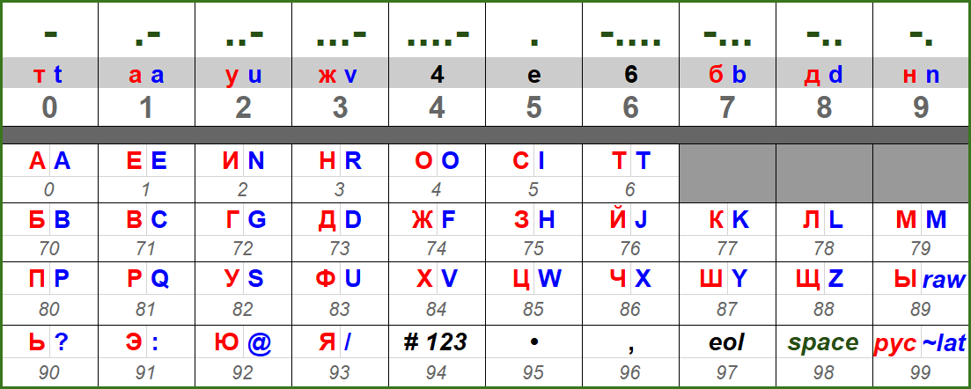

The Cyrillic letters are red, Latin letters are in blue, with the common symbols written in black. The grey numbers below the letters are their code. Converting the phrase “HELLO, WORLD.” Would be done as follows:
H E L L O “ “ W O R L D .
75 1 78 78 5 98 85 5 3 78 73 95

Grouped into five letter groups we get:
75178 78598 85537 87395

Subtracting our key:
75178 78598 85537 87395
68193 10738 34300 07453
----- ----- ----- -----
17085 68860 51237 80942

So our encrypted message would be:
17085 68860 51237 80942

If we found Morse Code digits to long, we could send use “Morse Shorts” that substitute letters for digits from the top part of the above figure:
17085 68860 51237 80942
ABTDE 6DD6T EAUVB DTN5U

The receiver at the other would transcribe the message, and convert into digits:
ABTDE 6DD6T EAUVB DTN5U
17085 68860 51237 80942

Then add the OTP key:
17085 68860 51237 80942
68193 10738 34300 07453
----- ----- ----- -----
75178 78598 85537 87395

Then convert the digits to letters again”
75 1 78 78 5 98 85 5 3 78 73 95
H E L L O “ “ W O R L D .

Returning to the figure we observe some features:



The “~” or code 99 is used for switching between Cyrillic and Latin alphabets in our clear text.

To enter numbers, use the “#” character, or 94 code, to indicate that digits follow, then enter the digits repeated once, followed by a final “#” or code 94. For the year “1989” we would have “#11998899#” entered.

The “raw” code 89 is to indicate raw codes like keys are being sent. We would use the 89 code, followed by three digits indicating the length of the raw data, the data itself, followed by another code 89 and three digit length:
89015 12345 67890 09876 89015

https://www.schneier.com/crypto-gram/archives/2002/1015.html#7
These drop off points are sometimes referred to as “dead letter boxes” or DLBs.

